Multiple-choice section – choose the correct answer

Question 1 [4.6] [10A]

When using the quadratic formula to solve x2 – 2x + 5 = 0, the values of a, b, c are (in order):

A 1, -2, 5 B -1, 2, -5 C 3, -1, 5 D 5, -2, 2

Question 2 [4.5] [10A]

The factors of 6x2 – x – 15 are:

A (2x – 3)(3x + 5) B 3(2x − 1)(x + 5) C (2x + 3)(3x - 5) D (6x – 5)(x + 3)

Question 3 [4.6] [10A]

Which equation has solutions 2 and -5?

A (x – 2)(x + 5) = 0 B (x + 2)(x – 5) = 0

C (2x – 5)(x – 7) = 0 D (2x – 5)(x + 5) = 0

Question 4 [4.6] [10A]

The quickest way to solve (x – 7)(x + 3) = 0 is by:

A completing the square B using the quadratic formula

C using the null factor law D multiplying the two numbers

Question 5 [4.2]

Completing the square to factorise x2 + 6x + 2 will give:

A (x + 3 + )(x – 3 – ) B (x + 3 + )(x + 3 – )

C (x + 3 + 7)(x + 3 – 7) D (x + 3 + )(x + 3 – )

Question 6 [4.4]

The y-intercept of the parabola with the equation y = x2 + 2x – 8 is:

**A** (0, -8) **B** -(0, 8)  **C** (-8, 0)  **D** (2, -8)

Question 7 [4.1]

The solutions to x(x + 7) = 0 are:

A 7, -7 B 0, 7 C 0, -7 D 1, -7

Question 8 [4.4]

The turning point (x, y) of the graph of y = (x – 12)2 + 5 is:

A (7, -5) B (12, 5) C (-5, -12) D (-12, -5)

Multiple-choice results: ___ / 8

Short answer section

Question 9 9 marks [4.1, 4.3]

Solve these equations using the null factor law.

(a) x(x + 2) = 0

(b) (x + 3)(x – 2) = 0

(c) 4x2– 9 = 0

(d) By completing the square and using the difference of two squares, solve the equation  
 x2 + 6x + 7 = 0.

Question 10 4 marks [4.1]

(a) Factorise x2 + 7x + 6.

(b) Use the null factor law to solve the equation x2 + 7x + 6 = 0.

Question 11 6 marks [4.1]

The area of a rectangle can be expressed as (x2 + 5x – 14) cm2.

(a) Factorise x2 + 5x – 14.

(b) What are the possible values of x if one of the dimensions of the rectangle is 13 cm?

(c) What are the possible values for the area?

Question 12 3 marks [4.2]

Tracey is factorising x2 – 10x + 15 using the completing the square method. Fill the gaps in her working.

x2 – 10x + 15

= x2 – 10x + ____ – ____ + 15

= (x2 – 10x +____) – ____

= (x – 5)2 – _____

= (x – 5)2 –

= (x – 5 + )(x – 5 –)

Question 13 5 marks [4.2, 4.3, 4.4]

(a) Show, by completing the square, that y = x2 + 4x – 5 can be expressed as y = (x + 2)2 – 9.

(b) State the coordinates of the turning point.

(c) Find the coordinates of the x-intercepts.

Question 14 4 marks [4.6] [10A]

Use the quadratic formula to determine whether the following equations can be solved for x. You need to give reasons for your answers, but you do not need to solve the equations.

(a) x2 + x + 7 = 0

(b) 2x2 – 5x – 12 = 0

Question 15 3 marks [4.6] [10A]

Solve 2y2 – 7y – 15 = 0 by splitting the middle term.

Question 16 3 marks [4.4]

Sketch the graph of y = -(x + 2)2 + 4 showing all relevant points.

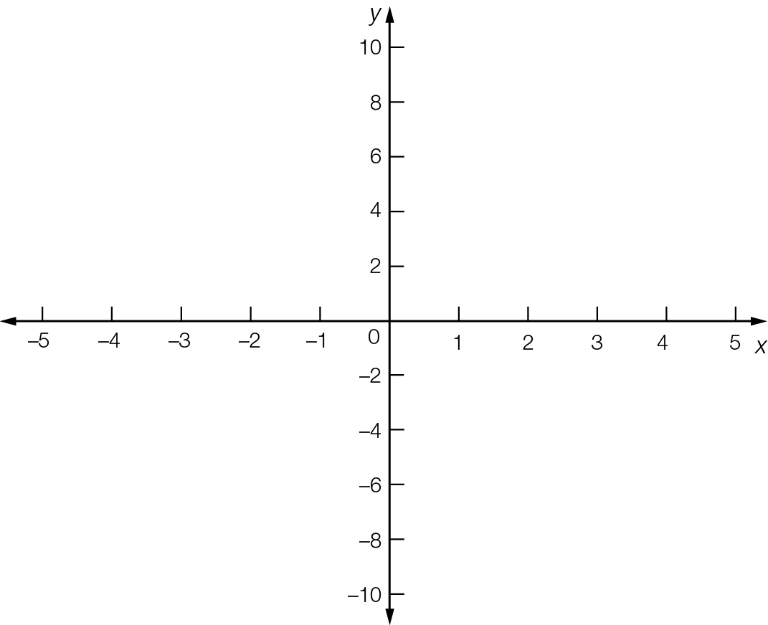

Question 17 3 marks [4.4]

The turning point for the graph with the equation y = a(x – h)2 + k is (4, 6) and y = 26 for x = 6. Calculate the values of a, h and k.

Short answer results: ___ / 40

Extended answer section

Question 18 6 marks [4.2, 4.3, 4.4]

A rocket launcher, which can be programmed to follow a variety of paths, is placed in a hole in the ground so that the missile appears to come out of the ground at zero height.

The launcher is initially set to follow the path h = -2(d – 20)2 + 800, where h represents the height of the rocket in metres and d is the horizontal distance travelled in kilometres.

(a) Sketch the pathway of the missile on the axes provided.

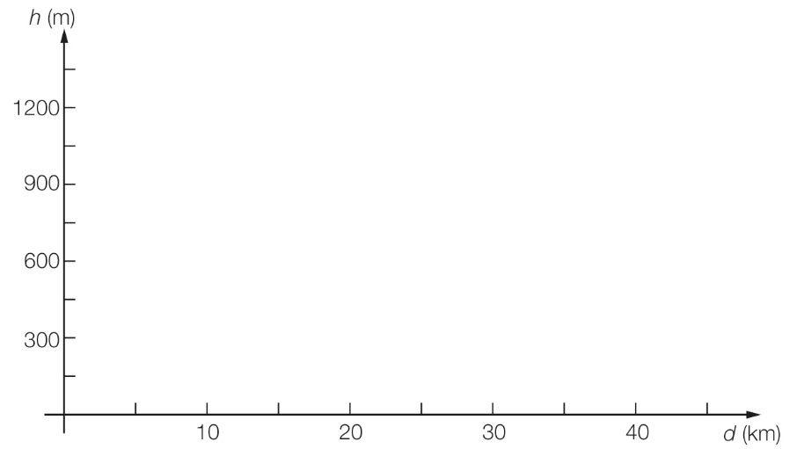

(b) Find the maximum height reached by the missile.

(c) Find the distance between the launch site and target.

Question 19 9 marks [4.4]

The equation y = 6x – x2 gives the height y metres of a projectile at time x seconds after it left the ground.

(a) Complete this table for the values of x and y.

|  |  |  |  |  |  |  |  |
| --- | --- | --- | --- | --- | --- | --- | --- |
| x | 0 | 1 | 2 | 3 | 4 | 5 | 6 |
| y |  |  |  |  |  |  |  |

(b) Plot the points to show the path of the projectile on the grid provided.



(c) State the turning point of the graph.

(d) Find the x- and y-intercepts of the graph.

(e) Factorise to find the two times when the projectile reaches a height of 5 m.

(f) Explain why there are two values found in part (e).

(g) Explain why there are no solutions where y = 10.

Extended answer results: ___ / 15

TOTAL test results: ___ / 63